Ladder & Steps Inspection Checklist
Company Name:
Ladder Ref / Number: |  | Department/ Location:
Ladder Type | 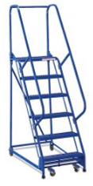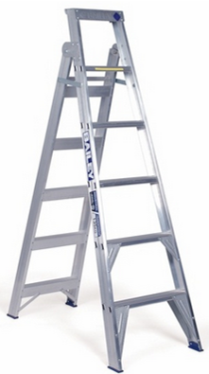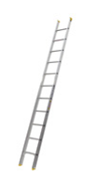  *Please circle all damage found on the above as appropriate
Ladder Material | Fibreglass |  |  | Aluminium |  |  |  |  | Wood
Where to check | What to check for |  |  | OK |  | Action Required |  |  | Remarks
Steps | Loose, cracked, bent or missing.
Rails/rungs/struts | Cracked, bent, split, or otherwise damaged/missing.
Rung locks (if applicable) | Loose, bent, missing or broken.
Labels | Missing, unreadable, or out of date.
Work platform | Cracked, loose, bent.
Spreaders/ wheels | Loose, broken, missing.
Handrails/stiles | Missing, worn, loose, or otherwise damaged.
Feet/supports | Missing, damaged, worn.
General overall | Rust, rot, suitability.
Condition: |  | Equipment tagged as damaged & removed from use
Condition: |  | Equipment is correct for the job, stable and in good condition
Inspected by: |  |  |  |  | Date:
Signature:

